**DAILY ONLINE ACTIVITIES SUMMARY**

|  |  |  |  |  |  |  |  |
| --- | --- | --- | --- | --- | --- | --- | --- |
| **Date:** | **1-07-2020** | | | | **Name:** | **B.A SOHANKUMAR** | |
| **Sem & Sec** | **4TH SEM A** | | | | **USN:** | **4AL18CS013** | |
| **Online Test Summary** | | | | | | | |
| **Subject** | | **----** | | | | | |
| **Max. Marks** | | **----** | | **Score** | | **----** | |
| **Certification Course Summary** | | | | | | | |
| **Course** | **COMPUTER VISION ESSENTIALS** | | | | | | |
| **Certificate Provider** | | | **GLA** | **Duration** | | | **5 HOURS** |
| **Coding Challenges** | | | | | | | |
| **Problem Statement:** Given two lists, sort the values of one list using the second list. | | | | | | | |
| **Status: EXECUTED** | | | | | | | |
| **Uploaded the report in Github** | | | | **YES** | | | |
| **If yes Repository name** | | | | **LOCKDOWN CODING** | | | |
| **Uploaded the report in slack** | | | | **YES** | | | |

**CERTIFICATION COURSE DETAILS:**

Course: Computer vision essentials

Completed modules today are Transfer Learning Principles and Practice,Hands-on Keras Demo: SVHN Transfer Learning from MNIST Dataset,SVHN_CNN_Transfer,cnn_mnist_weights.h5,Data set- SVHN Singe grey ,Visualization (run pacakge, occlusion experiment),Hands on demo -T-SNE,t-SNE MNIST and successfully completed the course.

 

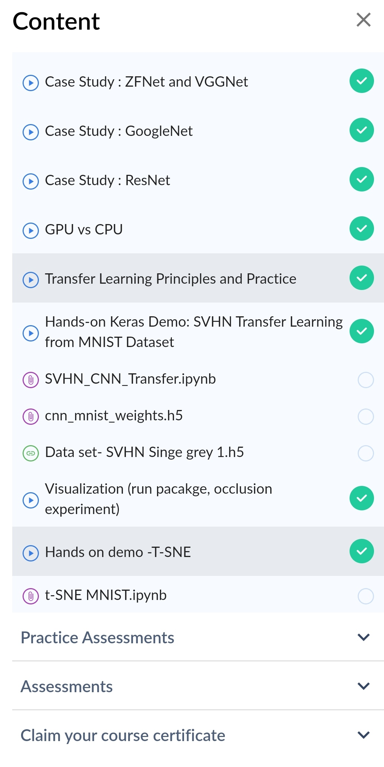COMPLETED MODULES

**CODING CHALLENGE DETAILS:**

1.Given two lists, sort the values of one list using the second list .Examples:

Input :list1 = ["a", "b", "c", "d", "e", "f", "g", "h", "i"] list2 = [ 0, 1, 1, 0, 1, 2, 2, 0, 1]

Output :['a', 'd', 'h', 'b', 'c', 'e', 'i', 'f', 'g'] Input : list1 = ["g", "e", "e", "k", "s", "f", "o", "r", "g", "e", "e", "k", "s"] list2 = [ 0, 1, 1, 0, 1, 2, 2, 0, 1] Output : ['g', 'k', 'r', 'e', 'e', 'g', 's', 'f', 'o']

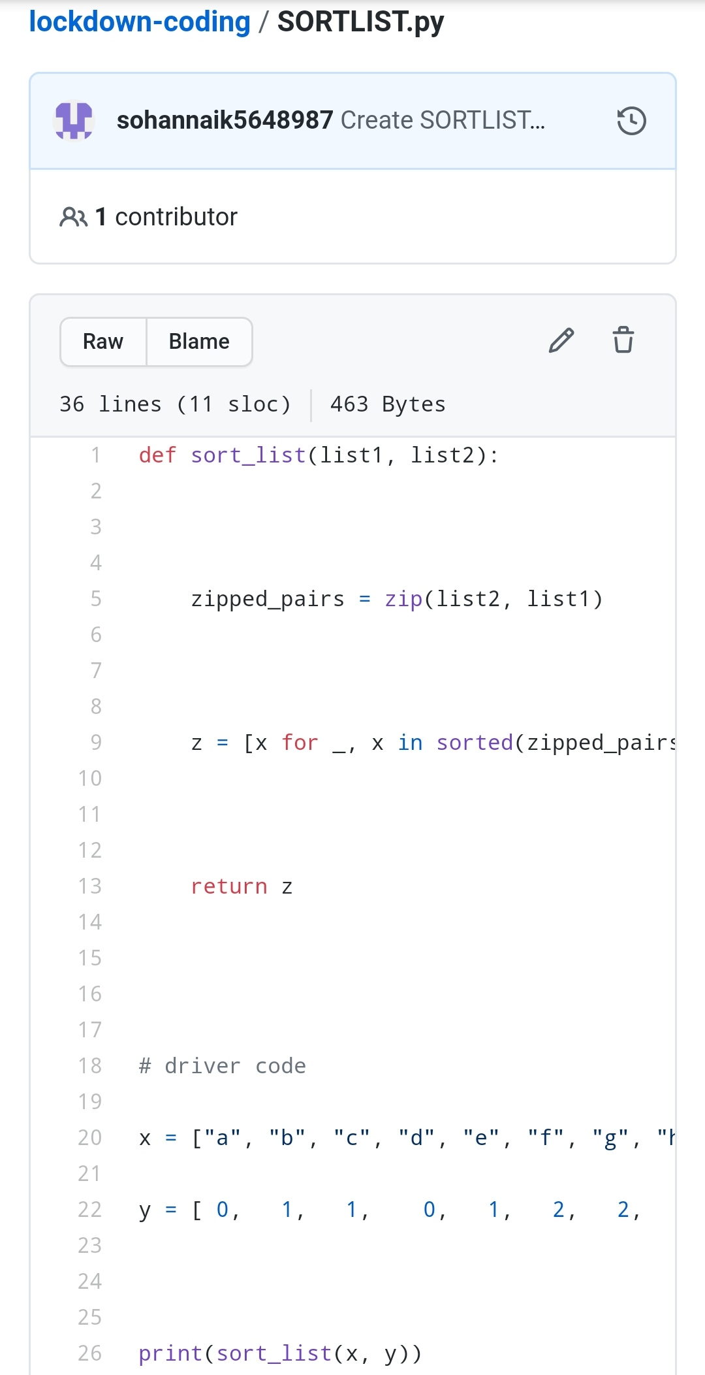

REPOSITORY LINK:https://github.com/sohannaik5648987/lockdown-coding